**Module Name:** To check Registration functionality of Official GSEB Website

**Test Case ID:** TEST2

**Webpage URL:** https://www.gsebeservice.com/Web/register

**Scenario ID: TS-A**

**Scenario:** Register with valid credentials  
**Test Steps:**

1. Enter Name
2. Choose Gender
3. Enter Birthdate
4. Select State
5. Select District
6. Enter Taluka (if Valid)
7. Enter Village(if Valid)
8. Enter Address
9. Enter Pin code
10. Enter Mobile Number
11. Enter Email ID
12. Enter Password
13. Click Register Button

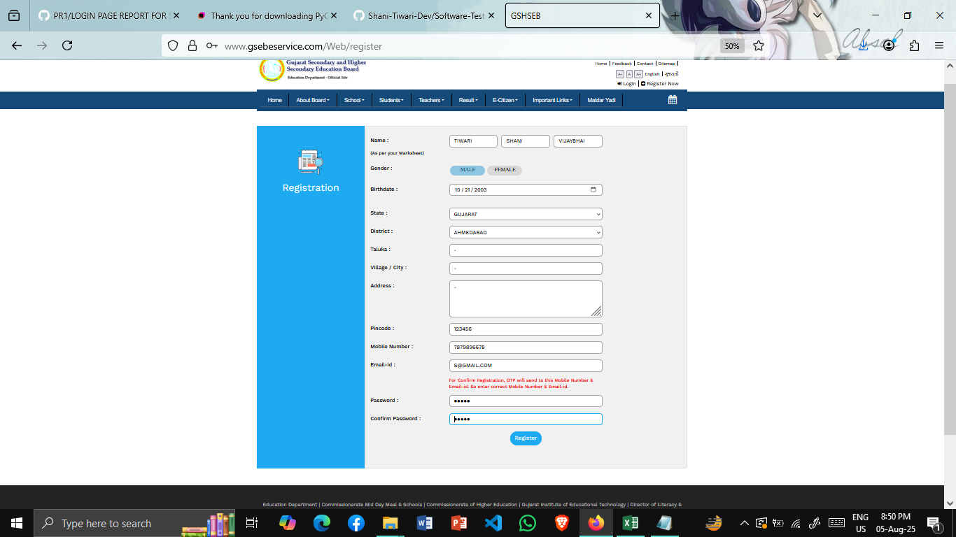**Screenshots:**

### 